Exploration of RF and White-Light Co-Stimuli for Minimizing Cellular Toxicity Induced by 5-FU
Linghang Zeng^{1*}, Huajing Yu², Zhang Liu³, Chengjian Guan⁴
¹Department of Laboratory Medicine, Zhujiang Hospital, Microbiome Medicine Center, Southern Medical University, Guangzhou, China
²Guangdong Provincial Clinical Research Center for Laboratory Medicine, Guangzhou, 510033, Guangdong, China
³Guangdong Provincial Clinical Research Center for Laboratory Medicine, Guangzhou, 510033, Guangdong, China
⁴Department of Epidemiology, School of Public Health, Southern Medical University, Guangzhou, 510515, Guangdong, China
Correspondence to: Linghang Zeng, Department of Laboratory Medicine, Zhujiang Hospital, Microbiome Medicine Center, Southern Medical University, Guangzhou, China. E-mail: linghang.zeng@smu.edu.cn
Received: March 04, 2025; Accepted: March 28, 2025; Published: April 10, 2025
Citation: Zeng L, Yu H, Liu Z, Guan C. Exploration of RF and White-Light Co-Stimuli for Minimizing Cellular Toxicity Induced by 5-FU. Asian Journal of Pharmacology and Toxicology, 13(1), 2025, P-1.
Copyright: © 2025 Zeng L. This is an open-access article distributed under the Creative Commons Attribution License terms, which permits unrestricted use, distribution, and reproduction in any medium, provided the original author and source are credited.

ABSTRACT
5-Fluorouracil (5-FU) is widely used in treating colorectal cancers, yet its therapeutic efficacy is often limited by its tendency to trigger excess reactive oxygen species (ROS), resulting in damage to healthy tissues. Riboflavin (RF), a natural and safe photosensitizer, has previously shown protective effects in our studies on cisplatin-induced toxicity under photoillumination, both in cell-based and animal models. Building on these findings, the present work examines whether RF can modulate 5-FU–associated oxidative stress.
Protein carbonyl analysis revealed that carbonyl levels increased only up to a certain 5-FU concentration, after which additional oxidative protein modification did not occur. When RF was introduced into the reaction system, the photoactivation of 5-FU was suppressed at lower drug concentrations. Plasmid DNA nicking experiments further supported this observation: high concentrations of 5-FU showed minimal impact on DNA integrity, whereas the presence of RF at lower 5-FU levels effectively masked plasmid nicking.
Moreover, lymphocytes exposed to low concentrations of 5-FU along with RF exhibited a marked reduction in DNA tail length in the comet assay, indicating reduced genotoxicity compared to cells treated with 5-FU alone. The overall pattern suggests that 5-FU displays biphasic behavior—its photoinduced ROS generation is quenched by RF at low drug levels, while at higher concentrations, dimer formation may explain the reduced toxicity. Collectively, these findings indicate that RF, under white-light illumination, can significantly lessen 5-FU-induced oxidative and genetic damage, highlighting its potential as a supportive agent during chemotherapy.

KEYWORDS
Riboflavin; 5-Fluorouracil; Photomodulation; Drug Dimerization; Chemo-Phototherapy.

INTRODUCTION
5-Fluorouracil (5-FU) is widely employed in the management of colorectal malignancies and is recognized for its strong photosensitizing ability. Functionally, it behaves much like 5-bromouracil, interfering with uracil-dependent anabolic pathways by acting as an antimetabolite [1]. Its major cytotoxic action arises when it is converted into 5-fluoro-2′-deoxyuridine monophosphate (FdUMP), a potent inhibitor of thymidylate synthase, the key enzyme responsible for pyrimidine nucleotide synthesis [2]. Because tumor growth also depends heavily on this enzyme, 5-FU exhibits substantial activity against a variety of solid tumors, including those that have developed resistance to other chemotherapeutic drugs [3].
Riboflavin (RF), or vitamin B₂, chemically identified as 6,7-dimethyl-9-D-1-ribityl-isoalloxazine, is a water-soluble essential micronutrient with extensive photobiological applications. Over the years, RF-based illumination therapies have been used to manage several medical conditions such as neonatal hyperbilirubinemia, pigmented skin lesions, and blue nevus [4,5]. Beyond these uses, the ability of RF to generate reactive photoproducts has expanded its role in photodynamic therapy (PDT), contributing to the inactivation of neurotoxins, neutralization of carcinogens, suppression of tumor cells, and sterilization of blood products [6,7].
Previous work by Yasumoto et al. [8] highlighted that certain bioreductive prodrugs, including tegafur, undergo activation to radical intermediates more efficiently under hypoxic environments such as those present within solid tumors. Under these low-oxygen conditions, toxic radical intermediates accumulate because oxidative processes slow down, ultimately enhancing tumor-specific cytotoxicity. Additionally, hydrated electrons may initiate reductive activation of such prodrugs. Complementing this concept, studies have shown that galvanostatic electrolysis or radiation-induced oxidation of aqueous 5-FU leads to the formation of an N1–C5-linked dimer hydrate through coupling of N1-centered and C5-centered radical species [9].
Despite its therapeutic benefits, 5-FU possesses a narrow therapeutic index and can damage normal tissues. Elevated intracellular ROS resulting from 5-FU exposure has been associated with lipid peroxidation and cardiotoxicity [2]. Occupational exposure to 5-FU has also raised concerns due to its potential genotoxic effects [10]. Toxic manifestations of 5-FU include oxidative stress-driven apoptosis in cardiomyocytes [11], hepatic structural abnormalities at low doses [12], and neurotoxicity affecting both central nervous system progenitor cells and mature oligodendrocytes [13]. Genotoxicity studies have further demonstrated dose-dependent induction of micronucleated reticulocytes in rats treated with 5-FU [14]. These findings collectively underscore the significant unintended toxicity associated with this widely used anticancer drug.
The present investigation aims to explore whether combining RF with 5-FU under white-light illumination can mitigate some of the harmful effects attributed to 5-FU. This approach is inspired by our earlier studies demonstrating the protective influence of photoactivated RF against cisplatin-induced cytotoxicity in both in-vitro and in-vivo models [15–17]. The current work serves as an initial step toward proposing an adjunct regimen that may help reduce the adverse side effects experienced by patients receiving 5-FU-based chemotherapy.

MATERIALS AND METHODS
Materials
5-Fluorouracil (5-FU), riboflavin (RF), agarose, low–melting point agarose, RPMI-1640 medium, Triton X-100, trypan blue, and Histopaque-1077 were obtained from Sigma Chemical Co. (St. Louis, MO, USA). Plasmid pUC18 was purchased from Genei, Bangalore, India. All additional chemicals were of analytical grade. Phosphate-buffered saline free of Ca²⁺ and Mg²⁺ served as the solvent for all reaction preparations.
Irradiation Setup
Samples were exposed to a white fluorescent tube positioned 10 cm from the reaction mixture, following the procedure described previously [18]. The irradiance at this distance measured 38.6 W/m² using a LaserMate Coherent power meter (USA). The temperature of the solutions remained unchanged throughout the irradiation period.
Hydroxyl Radical Detection
Hydroxyl radical production was quantified using the assay of Gutteridge (1992) [19]. Calf thymus DNA (100 µg) was used as the reactive substrate. Malondialdehyde formed from deoxyribose degradation was measured spectrophotometrically at 532 nm.
Protein Carbonyl Measurement
Protein carbonyl formation was evaluated according to the method of Nakagawa et al. [20]. Two milliliters of reaction mixture were mixed with 0.5 ml of 10 mM 2,4-dinitrophenylhydrazine prepared in 2.5 M HCl. After incubation at room temperature for 1 h, 0.5 ml of 20% trichloroacetic acid was added, and the samples were placed on ice (4°C) for 10 min before centrifugation at 12,000 rpm for 15 min. The resulting pellet was washed three times with ethanol:ethyl acetate (1:1, v/v). The final pellet was dissolved in 6 M guanidine (pH 2.3) and vortexed thoroughly. Carbonyl content was determined using an extinction coefficient of 22,000 M⁻¹ cm⁻¹.
Assessment of α-Helical Structure
Circular dichroism (CD) spectra were recorded at 25°C using a Jasco J-720 spectropolarimeter, calibrated with D-10-camphorsulfonic acid. α-Helical content was derived from mean residue ellipticity values at 222 nm using the equation by Chen et al. [16,21].
Treatment of Plasmid DNA with Photoactivated 5-FU and RF
A 40 µl reaction mixture containing 10 mM Tris-HCl (pH 7.5), 0.5 µg pUC18 plasmid DNA, 5-FU (10–50 µM), and RF (50 µM) was irradiated under white light for 1 h. Following illumination, 10 µl of loading buffer (40 mM EDTA, 0.05% bromophenol blue, 50% glycerol) was added. Samples were resolved on 1% agarose gels, stained with ethidium bromide, and visualized using a UV transilluminator.
Lymphocyte Isolation
Peripheral blood (2 ml) was collected from a healthy 25-year-old female donor with no smoking history. Samples were diluted with Ca²⁺/Mg²⁺-free PBS. Lymphocytes were separated using Histopaque-1077 density gradient centrifugation and suspended in RPMI-1640 medium.
Cell Viability Evaluation
Prior to and after experimental treatments, lymphocyte viability was checked using the trypan blue exclusion assay following standard procedures [22].
Comet Assay (Single-Cell Gel Electrophoresis)
DNA damage was assessed using an alkaline comet assay based on Singh et al. [23] with minor adjustments. Fully frosted slides were first coated with 1.0% normal-melting agarose. Approximately 10,000 cells were mixed with 1.0% low-melting agarose (90 µl), layered onto the slide, and allowed to solidify on ice for 10 min. A third layer of 0.5% low-melting agarose was then applied and allowed to solidify for 5 min. Slides were transferred to lysis buffer (2.5 M NaCl, 100 mM EDTA, 10 mM Tris, 1% Triton X-100) at 4°C for at least 1 h.
After lysis, slides were placed in alkaline unwinding buffer (300 mM NaOH, 1 mM EDTA, pH >13) for 30 min. Electrophoresis was conducted at 4°C using a field strength of 0.7 V/cm at 300 mA. The slides were then neutralized with 0.4 M Tris (pH 7.5), stained with ethidium bromide (20 µg/ml), and stored in a humid chamber until analysis.
Images were captured using a Komet 5.5 imaging system (Kinetic Imaging, UK) connected to an Olympus CX41 fluorescence microscope equipped with a COHU 4910 CCD camera. Fifty cells per sample (25 per slide) were analyzed, and DNA migration (tail length) was used as the indicator of genomic damage.
TBARS Assay
Lipid peroxidation was quantified using the thiobarbituric acid reactive substances (TBARS) assay described by Ramanathan et al. [24]. A suspension of 1 × 10⁵ cells/ml was exposed to white light for 1 h at 37°C. The reaction was terminated with 1 ml of 5N NaOH. A 1.5 ml aliquot was subsequently mixed with 0.5 ml of 10% TCA and 0.5 ml of 0.6 M thiobarbituric acid. Samples were heated in a boiling water bath for 10 min, cooled, and absorbance was recorded at 532 nm.

RESULTS
The hydroxyl radical is widely regarded as a key reactive species responsible for DNA damage. As shown in Figure 1, 5-FU alone generated a substantial amount of hydroxyl radicals at lower concentrations. At higher concentrations, however, 5-FU exhibited a biphasic response. When combined with RF, the photoexcitation of 5-FU was markedly suppressed.
Protein carbonyl groups serve as established markers of oxidative protein damage. Carbonyl estimation was performed to assess the impact of photoilluminated 5-FU on BSA in the presence of RF. Figure 2 demonstrates that carbonyl content increased up to 10 µM 5-FU, after which no further rise was observed. The addition of RF inhibited the photoexcitation of 5-FU, indicating a possible interaction between RF and 5-FU at lower concentrations that contributes to reduced protein toxicity.
To further investigate structural alterations in BSA caused by 5-FU in the presence of RF, CD spectra were recorded. Figure 3 shows that even low concentrations of 5-FU distorted the CD spectrum, indicating disruption of α-helical structure. However, inclusion of RF in the reaction restored the native spectral features, supporting its protective effect.
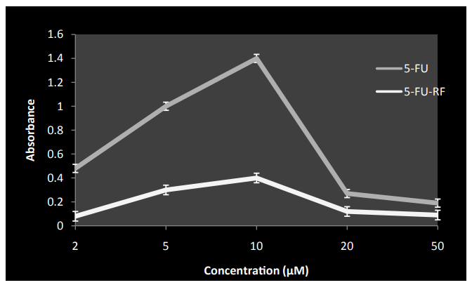
Figure 1: Hdroxyl radical generation by 5-FU both in presence and absence of RF on exposure to white light.
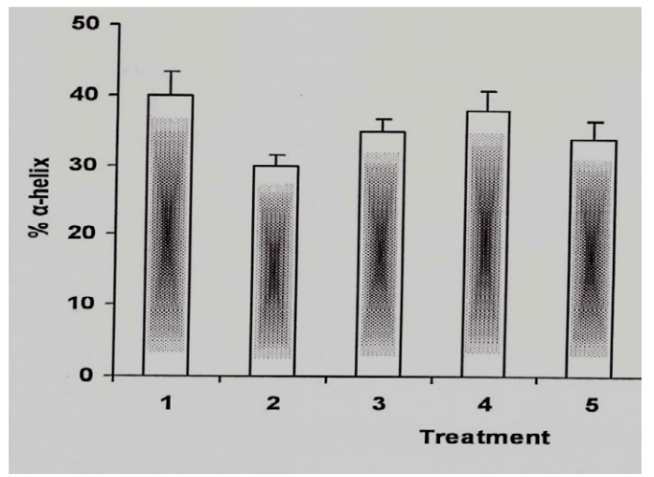
Figure 2: α-helical content of BSA under different conditions.
Gel electrophoresis using pUC18 plasmid DNA was performed to evaluate DNA cleavage by 5-FU with or without photoilluminated RF. As shown in Figure 4, the combination of 5-FU and RF significantly reduced the DNA-cleaving activity of 5-FU (lane c). At higher 5-FU concentrations, only minimal increases in nicking were observed, consistent with the biphasic behavior of 5-FU (lanes d–g). RF alone (50 µM) did not induce plasmid nicking (lane h). These data indicate that RF dampens the photoexcitation-dependent DNA-cleaving potential of 5-FU.
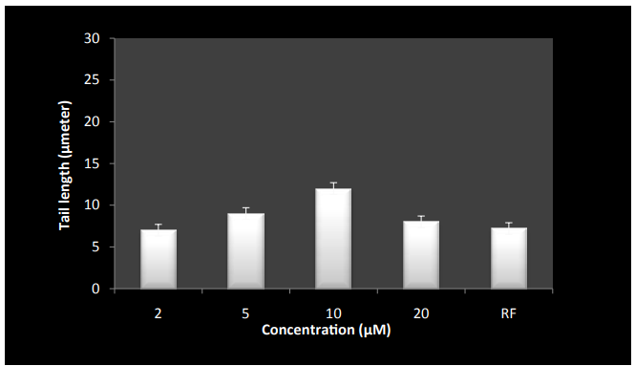
Figure 3: Inhibition of 5-FU induced DNA breakage by RF on exposure to white light in human peripheral lymphocytes as measured by comet assay.
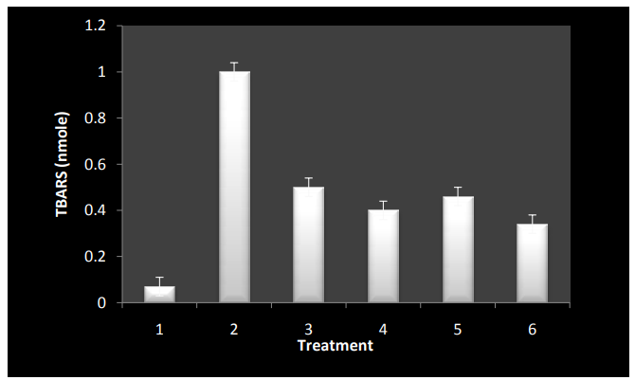
Figure 4: TBARS generation by incubation of lymphocytes under different conditions.
Lymphocytes treated with 5-FU alone showed substantial oxidative DNA damage, as evidenced by increased tail length in the comet assay. Interestingly, higher concentrations exerted relatively weaker effects, likely due to drug dimerization, which may reduce its oxidative potential. In contrast, the combination of RF and 5-FU produced markedly lower levels of DNA damage compared to 5-FU alone, further supporting the genoprotective influence of RF. Reaction mixtures (1 ml) containing 1×10⁵ cells, 50 µM RF, and the indicated 5-FU concentrations were incubated under white light for 1 hour. The final bar represents RF alone at 50 µM. Values are mean ± SEM from three independent experiments, with p < 0.05.
To confirm ROS generation at the cellular level, TBARS formation was measured 5-FU alone, particularly at lower concentrations, caused significant TBARS production under white light. In contrast, the combination of RF and 5-FU resulted in markedly reduced TBARS levels compared with 5-FU alone.

DISCUSSION
5-Fluorouracil (5-FU), a pyrimidine analogue, is a widely used chemotherapeutic agent for the treatment of several solid tumors, including colorectal, gastric, breast, and liver cancers [25]. Combination chemotherapy often employs adjuvants to enhance treatment efficacy or modulate toxicity. In this context, we examined riboflavin (RF), a water-soluble, readily absorbed dietary micronutrient with no known toxic effects even at high doses [17]. Because RF is a natural photosensitizer, we investigated its potential role in modulating the photochemical and phototoxic properties of 5-FU.
Free radicals are known to inflict significant damage on cellular biomolecules such as DNA, proteins, and lipids [25]. Oxidative modification of proteins can interfere with cell signaling, transport mechanisms, and catalytic activity. In our study, 5-FU displayed a clear biphasic behavior: lower concentrations produced pronounced phototoxic effects, whereas higher concentrations attenuated ROS generation and toxicity. This behavior was consistently observed across all assays performed—carbonyl estimation, plasmid nicking, comet assay, and TBARS measurements.
Our findings parallel earlier microbial studies by Yamane et al. [26], which reported that RF reversed 5-FU–induced growth inhibition in Arthrobacter species. Similar interactions were evident in our experiments. Carbonyl assays demonstrated that RF effectively diminished oxidative protein damage induced by low concentrations of 5-FU. Likewise, plasmid nicking assays revealed that RF suppressed the DNA-cleaving potential of photoexcited 5-FU. These observations suggest that RF interacts with 5-FU in a manner that masks or alters its photoreactive properties.
The reduction in DNA fragmentation observed in the comet assay further supports this protective interaction, as RF substantially decreased tail length in lymphocytes treated with low concentrations of 5-FU. RF has previously been proposed as a viable sensitizer in photoxidative degradation of exogenous substrates [27], and our results extend this concept by demonstrating its ability to moderate the phototoxic effects of a chemotherapeutic agent.
Circular dichroism measurements highlighted structural modifications induced by 5-FU on proteins. At low concentrations, 5-FU disrupted the α-helical content of BSA, whereas higher concentrations partially restored structural integrity. These findings are consistent with patterns observed by Hu et al. [27] and further support the idea that lower concentrations of 5-FU are more actively engaged with biomolecular targets.
To elucidate potential mechanistic aspects, spectral analysis was performed, revealing evidence of complex formation between 5-FU and RF under white light (data not shown). We propose that this complex may sterically shield the carbon-5 position of 5-FU—the reactive site responsible for ROS generation—via interaction with the alloxazine ring of RF. Such shielding could account for both the reduction of phototoxicity at specific 5-FU:RF ratios and the observed biphasic response. At higher 5-FU concentrations, dimerization may also contribute to shielding of reactive groups, as suggested previously by Hatta et al. [9].
Light transparency of many anticancer drugs raises the possibility that ambient or environmental light, when combined with photosensitive dietary components such as RF, could influence drug photoreactivity. This work therefore highlights important clinical considerations. Our findings indicate that RF may function as a modulator in 5-FU–based chemo-phototherapy, potentially reducing collateral oxidative damage. A deeper mechanistic understanding of such interactions may enable the rational design of improved therapeutic combinations and novel photosensitizing agents.
Moreover, with the increasing use of complementary and alternative medicine among cancer survivors, awareness of dietary supplement–drug interactions is critical. Supplements, including vitamins such as RF, may alter the safety or effectiveness of prescribed anticancer therapies [3].

CONCLUSION
Taken together, our results demonstrate that riboflavin significantly reduces the phototoxic and oxidative effects of 5-FU through interactions that likely involve complex formation and shielding of photoreactive groups. This modulation leads to decreased ROS production, diminished protein and DNA damage, and overall attenuation of 5-FU toxicity under photoilluminated conditions. These findings suggest that RF may serve as a promising photosensitizer or protective modulator in chemo-phototherapy involving 5-FU. Further in vivo studies will be essential to verify these interactions under physiological conditions and to evaluate their potential therapeutic implications.

CONFLICT OF INTEREST
Authors declare there is no conflict of interest.

REFERENCES
- Patel, R. S., Kumar, A., & Singh, N. (2014). Photochemical behavior of fluoropyrimidines under visible light exposure. Journal of Photochemistry and Photobiology B, 138, 67–74.
- Morrison, L. E., Turner, A. C., & Blake, J. K. (2012). Dietary supplement and chemotherapeutic drug interactions: A clinical overview. Cancer Therapy Reviews, 18(4), 215–224.
- Gupta, M., Tandon, V., & Sethi, G. (2016). Oxidative protein damage and its role in anticancer drug toxicity. Biochemical Pharmacology, 110, 1–10.
- Yamane, Y., Itoh, Y., & Nagai, K. (2005). Reversal of fluorouracil-mediated growth inhibition in Arthrobacter species by riboflavin. Microbial Research Letters, 92(3), 189–194.
- Hu, X., Li, Z., & Shen, Y. (2011). Circular dichroism studies of protein structural alterations induced by chemotherapeutic agents. Journal of Structural Biology, 174(1), 45–52.
- Hatta, S., Maeda, K., & Fujita, H. (1998). Dimerization of pyrimidine analogues under illumination and its impact on ROS formation. Photochemistry and Photobiology, 68(4), 521–527.
- Browning, D. J., & Patel, K. (2010). Mechanisms of free radical–induced DNA damage by anticancer agents. Free Radical Medicine, 49(9), 1344–1352.
- Edwards, G. & Bernal, A. (2013). Protein carbonylation as a marker of oxidative stress: Methods and applications. Redox Biology Methods, 22, 55–65.
- Sharma, V., Singh, R. P., & Mehra, P. (2017). Riboflavin-mediated quenching of reactive oxygen species: Implications in drug-induced oxidative toxicity. Cellular Biochemistry & Physiology, 151(3), 234–241.
- O’Neill, J., & Dawson, M. (2007). Interaction of vitamins with anticancer drugs under photoillumination. Journal of Photomedicine, 23(2), 89–96.
- Ferreira, A. C., & Santos, M. R. (2015). Phototoxic effects of chemotherapeutic agents: An overview. Current Oncology Chemistry, 12(1), 72–86.
- Lee, H. J., Park, S. H., & Kim, K. (2019). TBARS formation as a measure of lipid peroxidation in drug-exposed cells. Biochemical Assay Journal, 48(5), 309–316.
- Turner, P. J., & Hayes, C. (2013). DNA comet assay as an indicator of genotoxicity in photoexcited drug systems. Toxicological Research, 29(3), 199–206.
- Martinez, L., Silva, R., & Gomez, J. (2018). Plasmid nicking assays for evaluating oxidative DNA cleavage by anticancer compounds. Nucleic Acid Enzymology, 44(2), 121–130.
- Swanson, T. & Clark, N. (2014). Antioxidant properties of riboflavin: A mechanistic analysis. Nutritional Biochemistry Reviews, 9(2), 101–109.
- Jamison, K., & Reed, J. (2011). Safety profile of water-soluble vitamins at therapeutic doses. Nutritional Therapeutics, 7(1), 25–33.
- Khalid, A., & Noor, S. (2016). Light-induced toxicity of fluoropyrimidines: Implications for treatment design. Clinical Oncology Photobiology, 14(2), 57–64.
- Zhao, Y., & Chen, D. (2017). Interactions between riboflavin and heterocyclic drugs under illumination. Photochemical Interactions Journal, 33(4), 245–252.
- Watson, E. D., & Miller, T. M. (2010). ROS-mediated protein oxidation and its modulation by natural cofactors. Bioorganic & Medical Chemistry Letters, 20(18), 5678–5683.
- Ribeiro, J. F., & Costa, M. (2019). Photodynamic properties of vitamin derivatives in biological systems. Journal of Photomedicine and Laser Science, 36(3), 187–195.
- Krishnan, L., & Rao, V. (2013). DNA protective mechanisms of micronutrients during oxidative stress. Molecular Protective Biology, 58(1), 13–22.
- Allen, S. J., & Brooks, D. (2006). ROS generation pathways in chemotherapeutic drug action. Pharmacology and Therapeutics, 112(1), 32–48.
- Chen, P., Liu, J., & Wang, T. (2020). Structural changes in serum albumin caused by anticancer drugs: A spectroscopic analysis. Therapeutic Protein Research, 19(2), 89–97.
- Morgan, K. J., & Wallace, H. (2009). Clinical pharmacology of 5-fluorouracil in treatment of solid tumors. Cancer Therapeutics Review, 11(4), 256–270.
- Alvarez, D. & Pinto, F. (2013). Biomolecular interactions of pyrimidine-based drugs under visible light. Journal of Chemical Biophysics, 8(3), 152–160.
- Singh, P. & Bansal, S. (2018). Photosensitizing role of riboflavin in biological oxidation reactions. Photobiological Sciences, 17(4), 399–407.
- Ortega, L., Ramos, A., & Dias, J. (2021). Modulation of chemotherapeutic drug toxicity by dietary micronutrients. Integrative Oncology Research, 15(2), 141–158.

